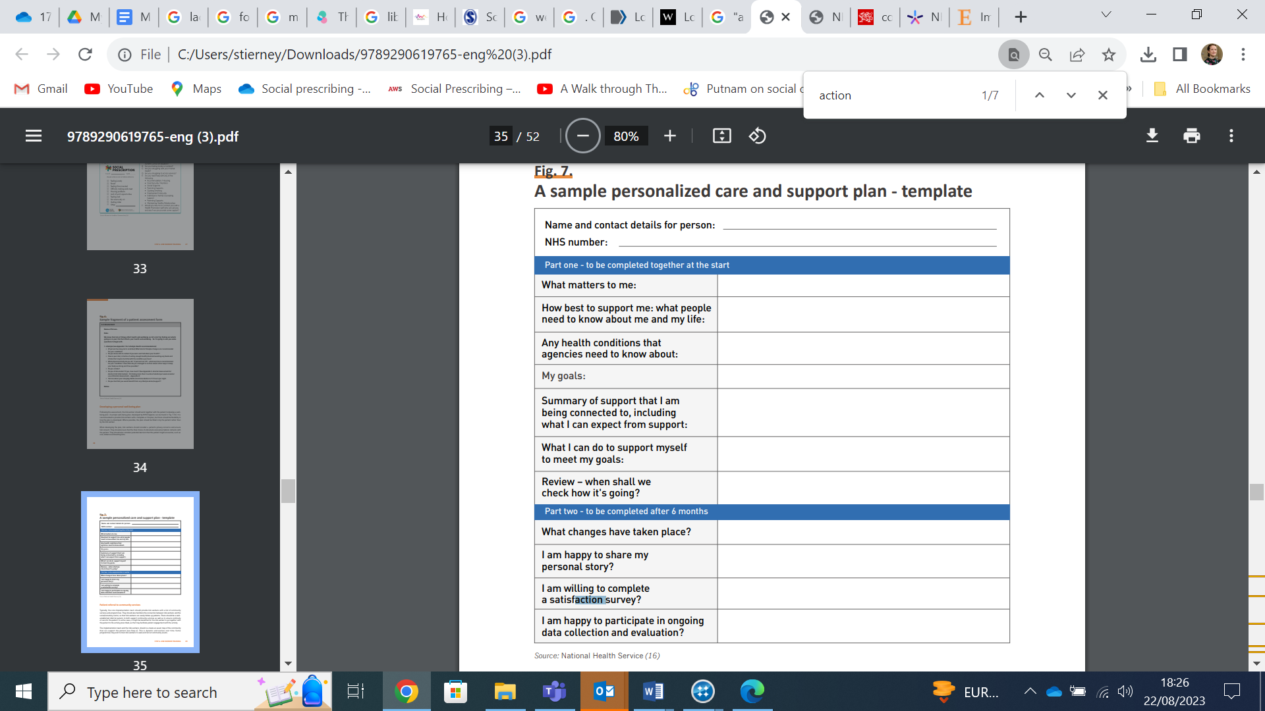

https://www.england.nhs.uk/personalisedcare/pcsp/

